Sub-module 5: RISC-V AXI Integration 2
1. Title 2
2. Objective 2
3. Theory (Multi-Level) 2
3.1 Beginner — Simple Intuition 2
3.2 Intermediate — Engineering View 2
3.3 Advanced — Signal/Architecture Level 3
4. Architecture / Concept 5
Full Bridge Architecture 5
Timing: CPU to AXI Write (Best Case) 5
5. Implementation 5
Files in This Module 5
Bridge Registers (from rtl/top.v) 6
Demo Testbench (tb_riscv_axi_lite.v) — What It Does 6
6. Lab / Hands-on Section 6
Step 1: Run the RISC-V AXI Integration Demo 6
Expected Terminal Output 6
Step 2: Trace the AXI Write Handshake in GTKWave 7
7. Waveform / Verification Insight 8
Write Transaction Checkpoint 8
Read Transaction Checkpoint 8
Bridge FSM in Real SoC (tb_top.v context) 8
8. Common Issues & Debug Tips 8
Protocol Violation: VALID Must Not Be Withdrawn 9
9. Summary 10

Sub-module 5: RISC-V AXI Integration
Course: PicoRV32 SoC with AXI-Lite & UART Integration
Lab Commands: make riscv_axi → make wave

1. Title
RISC-V AXI Integration — Bridging PicoRV32 Native Bus to AXI-Lite Protocol

2. Objective
By the end of this module, learners will be able to:
- Explain why a protocol bridge is needed between PicoRV32 and AXI peripherals
- Describe the CPU-to-AXI bridge state machine implemented in rtl/top.v
- Trace an AXI-Lite write/read transaction generated by the PicoRV32 native bus
- Run the make riscv_axi demo testbench and observe formatted handshake logs
- Identify the FSM states: ST_IDLE → ST_WR_AW → ST_WR_B → ST_RD_AR → ST_RD_R

3. Theory (Multi-Level)

3.1 Beginner — Simple Intuition
PicoRV32 speaks its own simple language: “here is an address and data, tell me when you are done.” The AXI peripheral speaks a more formal protocol: five separate conversations (channels) with specific handshake rules.
The AXI bridge is a translator that stands between them:
PicoRV32 AXI Bridge AXI Slave
(native bus) (protocol converter) (ROM/SRAM/UART)
mem_valid=1 ──► translates to ──► awvalid=1 (write addr)
+ wvalid=1 (write data)
waits for ◄── bvalid=1 (response)
mem_ready=1 ◄── signals done ──────────────────
The CPU never “sees” AXI at all — it just uses its simple mem_valid/mem_ready protocol, and the bridge handles all the AXI complexity underneath.

3.2 Intermediate — Engineering View
Why is the bridge needed?
PicoRV32’s native memory interface is a single channel with one valid/ready pair. AXI-Lite has five independent channels. A direct connection is not possible.
The bridge must: 1. Detect if the CPU wants a read (wstrb=0) or write (wstrb≠0) 2. Launch the appropriate AXI channel(s) 3. Wait for AXI completion across multiple clock cycles 4. Assert mem_ready when the AXI transaction finishes 5. Return mem_rdata for reads
FSM States (from rtl/top.v):
ST_IDLE (3'd0): Wait for cpu_mem_valid
ST_WR_AW (3'd1): Issue AW+W channels, wait for B response
ST_WR_B (3'd2): Wait for B channel (if AW/W already done)
ST_RD_AR (3'd3): Issue AR channel, wait for arready
ST_RD_R (3'd4): Wait for R channel data

3.3 Advanced — Signal/Architecture Level
Bridge internal signal mapping (rtl/top.v, lines 102–224):
// CPU outputs (inputs to bridge)
wire cpu_mem_valid; // CPU has a pending request
wire [31:0] cpu_mem_addr;
wire [31:0] cpu_mem_wdata;
wire [3:0] cpu_mem_wstrb;
// Bridge outputs (to CPU)
reg ready_r; // → cpu_mem_ready (one-cycle pulse)
reg [31:0] rdata_r; // → cpu_mem_rdata (latched read data)
assign cpu_mem_ready = ready_r;
assign cpu_mem_rdata = rdata_r;
Write Transaction FSM Detail:
ST_IDLE:
if (cpu_mem_valid && |cpu_mem_wstrb):
m_axi_awaddr ← cpu_mem_addr
m_axi_awvalid ← 1
m_axi_wdata ← cpu_mem_wdata
m_axi_wstrb_r ← cpu_mem_wstrb
m_axi_wvalid ← 1
→ ST_WR_AW
ST_WR_AW:
if (m_axi_awready && m_axi_awvalid): m_axi_awvalid ← 0
if (m_axi_wready && m_axi_wvalid): m_axi_wvalid ← 0
m_axi_bready ← 1
if (m_axi_bvalid && m_axi_bready): ready_r ← 1 → ST_IDLE
elif (!m_axi_awvalid && !m_axi_wvalid): → ST_WR_B
ST_WR_B:
if (m_axi_bvalid): ready_r ← 1 → ST_IDLE
Read Transaction FSM Detail:
ST_IDLE:
if (cpu_mem_valid && !|cpu_mem_wstrb):
m_axi_araddr ← cpu_mem_addr
m_axi_arvalid ← 1
→ ST_RD_AR
ST_RD_AR:
if (m_axi_arready && m_axi_arvalid):
m_axi_arvalid ← 0
m_axi_rready ← 1
→ ST_RD_R
ST_RD_R:
if (m_axi_rvalid && m_axi_rready):
rdata_r ← m_axi_rdata
m_axi_rready ← 0
ready_r ← 1
→ ST_IDLE

4. Architecture / Concept

Full Bridge Architecture
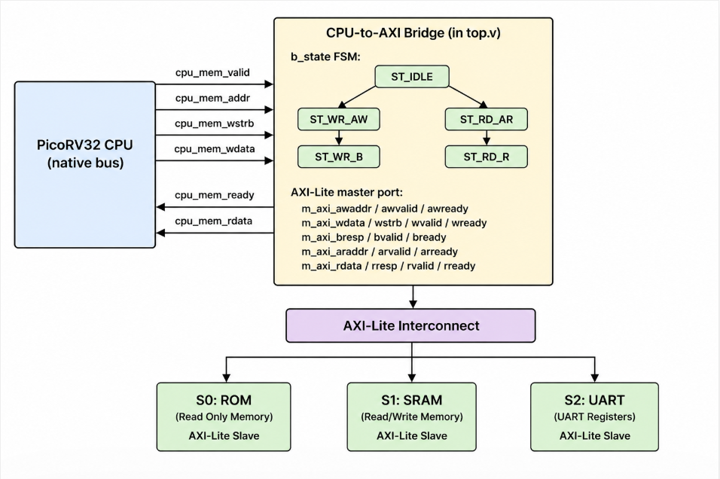

Timing: CPU to AXI Write (Best Case)
Cycle: 1 2 3 4 5
CPU: valid=1 valid=1 valid=1 ready=0 mem_ready=1
Bridge: ST_IDLE ST_WR_AW (↓AW↓W) ST_WR_B ST_IDLE
AXI: awvalid=1 awvalid=1 awready=1 bvalid=1 bready=1
wvalid=1 wvalid=1 wready=1
The bridge introduces 2–4 cycle latency per AXI transaction, which is acceptable for MMIO register access.

5. Implementation

Files in This Module
File | Role
rtl/top.v | Contains the CPU-to-AXI bridge FSM (lines 91–224)
tb/tb_riscv_axi_lite.v | Self-contained demo TB showing step-by-step AXI handshake
rtl/axi_lite_interconnect.v | AXI interconnect that bridge connects to
rtl/axi_decoder.v | Address decoder used by interconnect

Bridge Registers (from rtl/top.v)
// ASIC-clean: no inline initializers — all driven by reset
reg [31:0] m_axi_awaddr; reg m_axi_awvalid;
reg [31:0] m_axi_wdata; reg [3:0] m_axi_wstrb_r; reg m_axi_wvalid;
reg m_axi_bready;
reg [31:0] m_axi_araddr; reg m_axi_arvalid;
reg m_axi_rready;
reg [2:0] b_state;
reg [31:0] rdata_r;
reg ready_r;

Demo Testbench (tb_riscv_axi_lite.v) — What It Does
This testbench simulates a CPU issuing an AXI write then read at address 0x1000_0000 (UART base): 1. Master asserts m_awaddr=0x10000000, m_awvalid=1, m_wdata=0xA5, m_wvalid=1 2. Slave responds: s_awready=1, s_wready=1 → write data stored in slave_reg[0] 3. Slave asserts s_bvalid=1 (OKAY response) 4. Master reads back: m_arvalid=1 → s_arready=1 → s_rdata=0xA5 → s_rvalid=1 5. Checks captured_rdata == TEST_DATA → prints “Success”

6. Lab / Hands-on Section

Step 1: Run the RISC-V AXI Integration Demo
cd /home/deep/nielit/projects/tested_projects/picorv32_soc
make riscv_axi
This: 1. Cleans obj_axi/ 2. Compiles only tb/tb_riscv_axi_lite.v (self-contained, no RTL files needed) 3. Runs ./obj_axi/sim_axi → produces tb_riscv_axi_lite.vcd 4. Opens GTKWave

Expected Terminal Output
---- Simulation Start ----
[0-10 ns] System in reset
[10 ns] Reset released → CPU and AXI start working
-------------------------------
[50 ns] AXI WRITE TRANSACTION
-------------------------------
CPU wants to write data
Step 1: Send Address
AWADDR = 0x10000000
AWVALID = 1 → CPU says "address is ready"
AWREADY = 1 → Bus says "address accepted"
Step 2: Send Data
WDATA = 0x000000A5
WVALID = 1 → CPU says "data is ready"
WREADY = 1 → Bus says "data accepted"
Step 3: Write Response
BVALID = 1 → Bus says "write completed"
BREADY = 1 → CPU accepts response
Result: Data 0xA5 successfully written to address 0x10000000
-------------------------------
[110 ns] AXI READ TRANSACTION
-------------------------------
CPU wants to read data
Step 1: Send Address
ARADDR = 0x10000000
ARVALID = 1 → CPU requests read
ARREADY = 1 → Bus accepts request
Step 2: Get Data
RDATA = 0x000000A5
RVALID = 1 → Bus sends data
RREADY = 1 → CPU accepts data
Result: Read value = 0xA5 (same as written)
-------------------------------
Final Conclusion:
Write = Success
Read = Success
AXI-Lite integration is working correctly
---- Simulation End ----

Step 2: Trace the AXI Write Handshake in GTKWave
gtkwave tb_riscv_axi_lite.vcd &
Add:
clk
reset
m_awaddr[31:0] ← master write address
m_awvalid
s_awready ← slave accepts address
m_wdata[31:0] ← master write data
m_wvalid
s_wready ← slave accepts data
s_bvalid ← slave response
m_bready ← master ready for response
m_araddr[31:0] ← master read address
m_arvalid
s_arready ← slave accepts address
s_rdata[31:0] ← slave read data
s_rvalid ← slave data valid
m_rready ← master ready for data

7. Waveform / Verification Insight

Write Transaction Checkpoint
In GTKWave, look for the cycle where m_awvalid AND s_awready = 1 simultaneously — this is the AW handshake. Measure the delay from m_awvalid rising to s_awready rising. In this testbench it is 1 cycle (ideal slave).

Read Transaction Checkpoint
Look for m_arvalid AND s_arready = 1 → AR handshake. Then s_rvalid AND m_rready = 1 → R handshake. Confirm s_rdata = 0xA5 at the R handshake moment.

Bridge FSM in Real SoC (tb_top.v context)
When running make soc, add b_state[2:0] to see the bridge FSM:
State value Meaning
0 (ST_IDLE) Waiting for cpu_mem_valid
1 (ST_WR_AW) AW+W presented to interconnect
2 (ST_WR_B) Waiting for B (write response)
3 (ST_RD_AR) AR presented to interconnect
4 (ST_RD_R) Waiting for R (read data)
The transition 0→1→0 or 0→3→4→0 visible in waveforms corresponds directly to each CPU instruction that accesses memory.

8. Common Issues & Debug Tips
Issue | Likely Cause | Fix
Bridge stuck in ST_WR_AW | m_axi_awready never asserts | Check interconnect routing — is wr_sel correct?
Bridge stuck in ST_RD_R | m_axi_rvalid never asserts | Check slave’s read path — is r_valid_r never set?
mem_ready never pulses | Bridge FSM never reaches ready_r ← 1 | Trace b_state in waveforms
CPU sees wrong rdata | rdata_r captured at wrong cycle | Ensure rdata_r ← m_axi_rdata happens only when rvalid=1 AND rready=1
Bridge issues both AW and AR | CPU wstrb ambiguous | Confirm decoder uses |cpu_mem_wstrb != 0 → write
GTKWave shows no transitions | Wrong VCD file | Use ls -la *.vcd to verify tb_riscv_axi_lite.vcd was generated

Protocol Violation: VALID Must Not Be Withdrawn
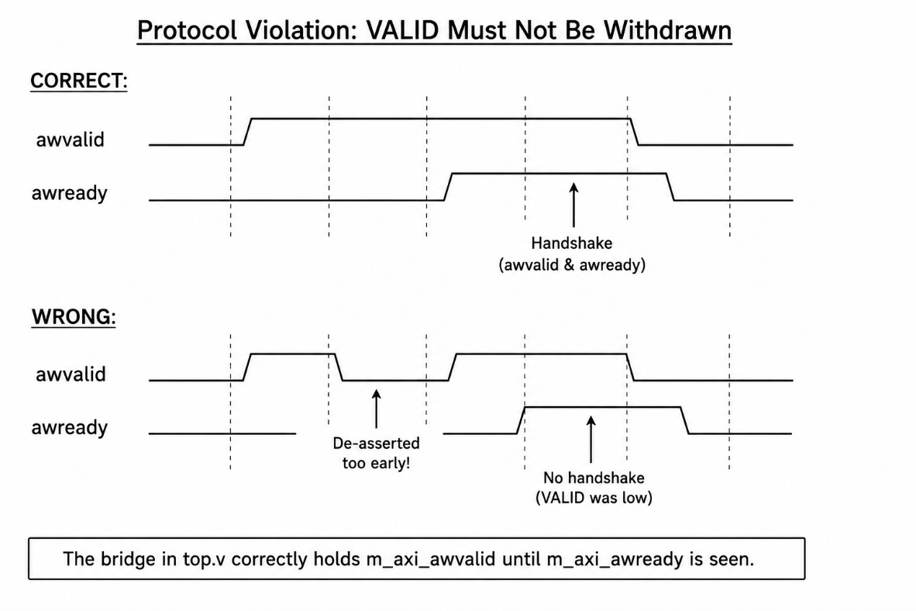

9. Summary
Concept | Detail
Bridge purpose | Converts PicoRV32 native (mem_valid/ready) to AXI-Lite 5-channel protocol
FSM states | ST_IDLE, ST_WR_AW, ST_WR_B, ST_RD_AR, ST_RD_R
Write latency | 3–4 cycles (AW+W handshake + B response)
Read latency | 2–3 cycles (AR handshake + R data)
Bridge location | Embedded in rtl/top.v (lines 91–224)
ASIC-clean | All bridge registers reset-driven; no inline initializers
Lab file | tb/tb_riscv_axi_lite.v — fully self-contained, no RTL dependencies
Lab result | Write 0xA5 to 0x10000000, read back 0xA5 → Success
This module forms the critical connection between the RISC-V ISA world (Sub-modules 1–4) and the AXI peripheral world (Sub-modules 6–8). Every firmware memory access in the final SoC passes through this bridge.

Previous: Sub-module 4 — MMI RISC-V + UART
Next: Sub-module 6 — AXI + UART Integration

